Security in Computing Practical 2
Configure AAA Authentication on Cisco Router (R1)
Practical 2: Configure AAA Authentication on Cisco routers
Topology:

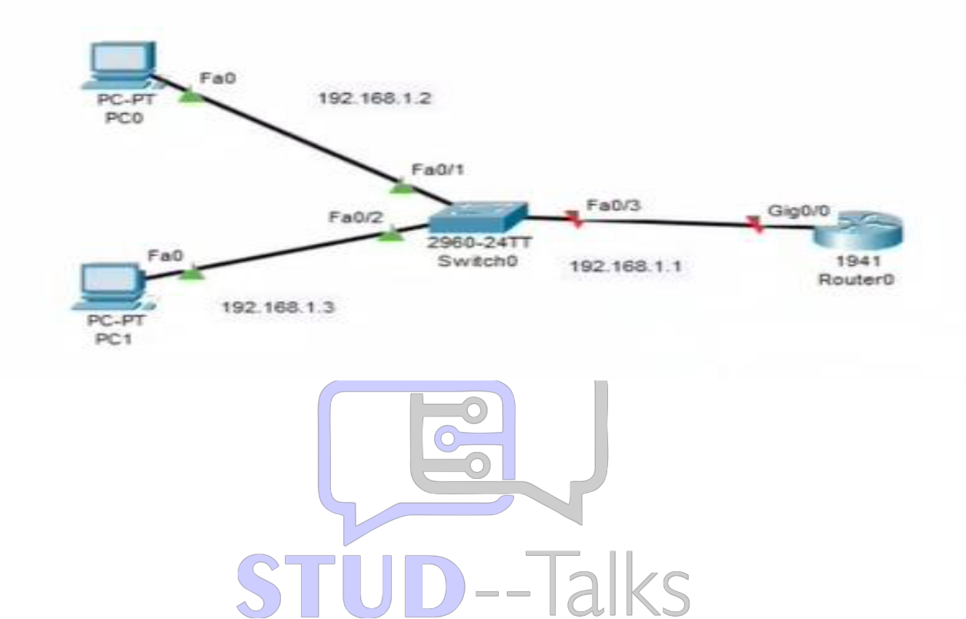

Router R1 – Full Configuration
enable
conf t
hostname R1
enable secret enpa55
line vty 0 4
password vtypa55
login
exit
interface g0/0
ip address 192.168.1.1 255.255.255.0
no shutdown
exit
router ospf 1
network 192.168.1.0 0.0.0.255 area 0
area 0 authentication message-digest
exit
interface g0/0
ip ospf message-digest-key 1 md5 pa55
exit
username admin secret adminpa55
aaa new-model
aaa authentication login default local
line console 0
login authentication default
exit
ip domain-name ccnasecurity.com
crypto key generate rsa
1024
aaa authentication login SSH-LOGIN local
line vty 0 4
login authentication SSH-LOGIN
transport input ssh
exit
end
wr

Verification Steps
1. show ip interface brief
2. show ip ospf interface
3. ping between PCs
4. Login using:
Username: admin
Password: adminpa55
5. ssh -l admin 192.168.1.1
6. show ip ssh

Practical 2: AAA Authentication
- On R1:
  - show running-config | section aaa: To verify that aaa new-model and authentication lists are active.
  - show ip ssh: To check the SSH version and authentication settings.
- Testing Login:
  - Console/VTY Login: Attempt to log in; the router should prompt for the username admin and password adminpa55.
  - ssh -l admin 192.168.1.1: To test the AAA-controlled SSH access.

Practical 2: Local AAA Authentication
On Router R1
- Console Verification: Exit the session. When you press Enter, it must prompt for Username: admin and Password: adminpa55.
On PCs (PC0, PC1)
- VTY Verification: Run ssh -l Admin 192.168.1.1. It should authenticate using the local database.

Viva Questions
AAA = Authentication, Authorization, Accounting
Authentication = verifies user identity
SSH is secure, Telnet is not
Local AAA uses router database

